Livingway Christian Academy, Inc.

6415 North Pearl Street

Jacksonville, Florida 32208

quire

**FES-EO and FTC TUITION and FEES**

**STUDENTS ENROLLED IN KINDERGARTEN – 3rd GRADE**

**2023 – 2024 SCHOOL YEAR**

|  |  |
| --- | --- |
| **Items** | **Cost** |
| **Testing** | **100.00** |
| **Registration Fee** | **400.00** |
| **Yearly Tuition** | **6,200.00** |
| **Curriculum** | **560.00** |
| **Uniform Package** | **90.00** |
| **Technology Fee** | **138.00** |
| **Activity Fee** | **100.00** |
| **Other** | **413.00** |
|  |  |
|  |  |
| **TOTAL** | **8,001.00** |

**Livingway Christian Academy is an Educational Ministry of Livingway Christian Fellowship Church International, Inc.**

***Dr. Anthony L. Speight, Founder/Bishop***

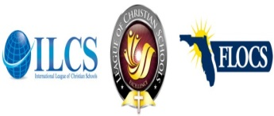

***ACCREDITATED***

**Livingway Christian Academy**

*School of Excellence*

6415 North Pearl Street, Jacksonville, Florida 32208

Phone: (904) 765-8700 Facsimile: (904) 924-7888